Mr. Ed, Butterfly Girl and the Frog Prince
If all good stories begin with once upon a time, then this one should too.
One morning as I was pouring my first cup of coffee, Ed walked in to my kitchen, and with that straight face that he puts on before delivering an absolutely absurd remark, says to no one in particular and anyone present, ''In my next life, I want to come back as a frog'. I laughed. Over the years, we have thought of Ed and that morning many times, and laughed.
The day before, Linda and Ed had landed at the airport in Rhode Island on their way to one of Ed's reunions. We'd picked them up, done a bit of sightseeing and brought them to our home. They spent the night in somewhat dubious comfort on our hide-a-bed in the den, a room with walls lined with Central American masks collected on our many trips south. Centered over the head of the bed, is the largest and most colorful mask, the Butterfly Girl. She has the head of a maiden, wings and antennae of a butterfly, tail of a mermaid and the voluptuous bosom of…. she's lovely. Clutching her bosom with arms outstretched and nestled in between, is a happy green frog. Ed couldn't have helped but look up at her as he drifted off to sleep.
Ed was the jokester. He made us laugh. When I think back to all the jokes he told us, none have ever made me smile more than that morning's one liner.
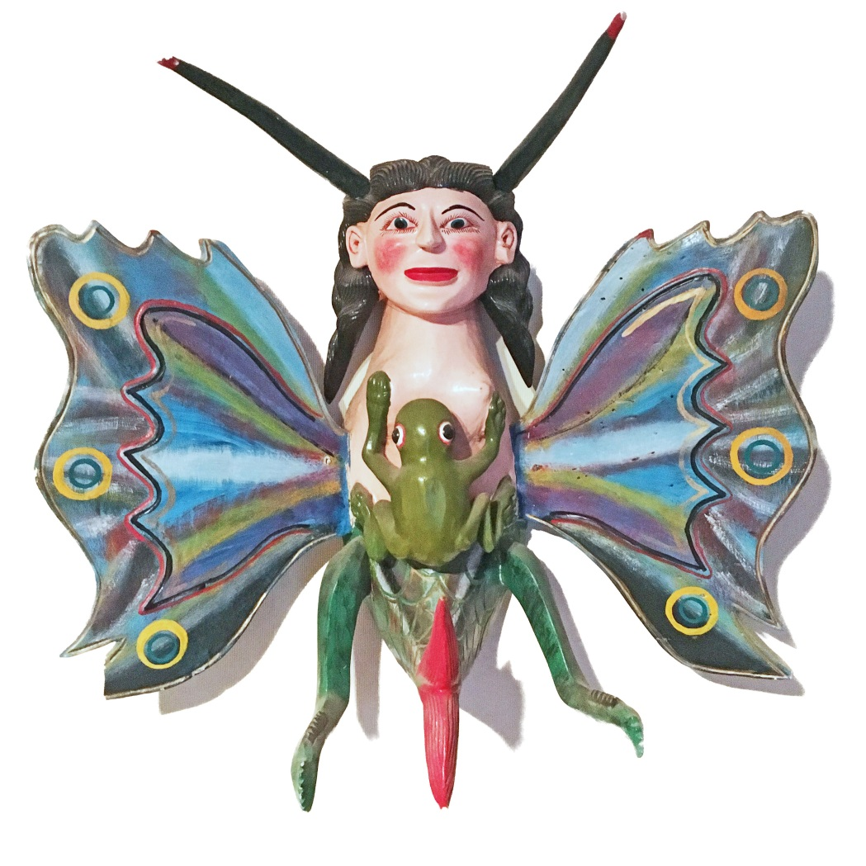

The butterfly girl is a truly beautiful piece. She is a fertility mask. Part butterfly, she is a creature that lives both on the earth and in the air. She morphs from a lowly earthbound caterpillar to the most beautiful and ethereal butterfly. With her mermaid tail, she exists in all worlds: earth, sea and air.
The frog too, transcends: morphing from a tadpole, existing only in and under water, to frog, living on land and water, an air breather.
I know there is a lesson here. I can feel it, touch it with my mind but not quite express it in words. Ed has left his earthly body. He has, like the butterfly and the frog, left the old one behind to become something new, and wonderful.
(If Ed gets his wish and comes back as a frog, I think he will be the Frog Prince. You know how that story ends. )

Thanks, Ed.

Judy Jacobs
1.29.19

